Assessment
N+ - Network security, Maintenance and Troubleshooting procedures
Section-A

- Explain the selection process for CPU, RAM, and storage specifications to ensure hardware compatibility and prevent performance bottlenecks for a startup team performing concurrent development and video conferencing tasks.

- For a startup team that performs concurrent software development and video conferencing, selecting the right CPU, RAM, and storage is essential to ensure hardware compatibility and avoid performance bottlenecks. The components should be chosen so that they work well together and meet both current and future workload requirements.
- CPU (Central Processing Unit) Selection
The CPU is the main processing unit of the computer and greatly affects multitasking performance.
Selection Criteria:
  - Choose a modern processor such as Intel Core i5/i7 (12th generation or newer) or AMD Ryzen 5/7 (5000 series or newer).
  - Prefer 6–8 cores and 12–16 threads for smooth multitasking.
  - Ensure the CPU supports virtualization if developers use virtual machines or Docker.
  - Verify that the CPU is compatible with the motherboard socket (e.g., LGA1700 for Intel or AM5 for newer AMD processors).
Why it matters: • Developers often run IDEs, browsers, databases, and containers simultaneously.
  - Video conferencing applications (Zoom, Microsoft Teams, Google Meet) also require CPU resources.
  - A multi-core processor prevents slowdowns when multiple applications run at the same time.

- RAM (Memory) Selection
RAM temporarily stores data that active applications need.
Selection Criteria:
  - Minimum 16 GB DDR4 or DDR5 RAM per system.
  - 32 GB RAM is recommended for developers using virtual machines, Android Studio, or multiple development tools.
  - Ensure the motherboard supports the RAM type (DDR4 or DDR5), speed, and maximum capacity.
  - Use dual-channel memory (e.g., 2 × 8 GB or 2 × 16 GB) for improved performance.
Why it matters: • Insufficient RAM causes frequent disk swapping, making the system slow.
  - Adequate RAM allows developers to keep multiple applications open while attending video meetings without lag.

- Storage Selection
Storage affects boot time, application loading, and file access speed.
Selection Criteria:
  - Use an NVMe SSD instead of a traditional HDD.
  - Minimum 512 GB SSD for operating system, development tools, and projects.
  - 1 TB SSD is recommended for larger code repositories, virtual machines, and multimedia files.
  - Ensure the motherboard has the required M.2 NVMe slot and supports the SSD generation (PCIe Gen3 or Gen4).
Why it matters:
  - SSDs provide much faster boot and application loading times than HDDs.
  - Faster storage improves compilation speed, file transfers, and overall responsiveness.
  - Prevents delays when opening large projects or switching between applications.

Ensuring Hardware Compatibility
To ensure all components work together:
- Verify CPU and motherboard socket compatibility.
- Match RAM type (DDR4/DDR5) with motherboard specifications.
- Confirm motherboard supports the chosen SSD interface (M.2 NVMe).
- Use a power supply (PSU) with sufficient wattage for all components.
- Check BIOS support for newer processors if required

Preventing Performance Bottlenecks
A balanced system avoids one component limiting the performance of others.
Component | Recommended Specification | Benefit
CPU | Intel Core i5/i7 or AMD Ryzen 5/7 (6–8 cores) | Smooth multitasking and faster code compilation
RAM | 16 GB minimum, 32 GB recommended | Handles multiple applications without slowdown
Storage | 512 GB–1 TB NVMe SSD | Fast boot, quick application loading, and rapid file access

- Explain how system resource allocation and hardware bottlenecks contribute to performance degradation after the deployment of resource-intensive background applications like antivirus software.

When resource-intensive background applications, such as antivirus software, are deployed, they continuously consume system resources. If these resources are not allocated efficiently or the hardware is insufficient, the overall system performance degrades.
System Resource Allocation
System resource allocation refers to how the operating system distributes CPU time, memory (RAM), storage access, and network bandwidth among running applications. CPU Allocation
- Antivirus software continuously scans files and monitors system activity.
- This consumes CPU cycles that could otherwise be used by user applications.
- As a result, applications may respond more slowly, especially during full system scans.
Example: While compiling code, an antivirus scan may increase CPU usage to 80–90%, causing longer compilation times.
Memory (RAM) Allocation
- Antivirus programs load services and virus definition databases into RAM.
- If RAM becomes insufficient, the operating system starts using virtual memory (paging), which is much slower than physical RAM.
- This increases application loading times and reduces responsiveness.
Disk (Storage) Allocation
- Antivirus software frequently reads and scans files stored on the disk.
- Simultaneous access by the antivirus and user applications creates disk contention.
- On HDDs, this significantly slows file access; on SSDs, the impact is smaller but still noticeable.
Network Resource Allocation • Antivirus applications may download virus definition updates or upload security logs.
- This consumes network bandwidth, reducing available bandwidth for video conferencing or cloud-based applications.
Hardware Bottlenecks
A hardware bottleneck occurs when one component cannot keep up with the workload, limiting overall system performance.
CPU Bottleneck
- A dual-core or older processor may struggle to run antivirus scans alongside development tools and video conferencing.
- High CPU utilization causes slower application performance and delayed responses.
RAM Bottleneck
- Systems with only 8 GB RAM may run out of available memory when multiple applications and antivirus software are active.
- Frequent paging to disk causes noticeable lag and slower multitasking.
Storage Bottleneck • Traditional HDDs have slower read/write speeds than SSDs.
- Continuous antivirus scanning increases disk activity, resulting in longer boot times and slower application launches.
Network Bottleneck
• If the internet connection has limited bandwidth, antivirus updates can interfere with video conferencing, causing buffering or poor call quality.
Effects on Overall System Performance
The combined impact of resource allocation and hardware bottlenecks can lead to:
- Slower application startup.
- Increased program response time.
- Reduced multitasking performance.
- Longer software compilation and file transfer times.
- Lag during video conferencing.
- Higher system boot times.
- Reduced overall productivity.

Example Scenario
A developer is:
- Running Visual Studio Code
- Using Docker containers
- Participating in a Microsoft Teams meeting
- While a full antivirus scan is running
The antivirus consumes CPU, RAM, and disk resources simultaneously. If the computer has only 8 GB RAM, a dual-core CPU, and an HDD, the system may experience:
- Slow code compilation.
- Lag during the video call.
- Delayed file access.
Overall sluggish performance.

- Explain the systematic troubleshooting process for resolving peripheral hardware failure caused by driver incompatibility or operating system conflicts when a device functions inconsistently across different workstation.

Systematic Troubleshooting Process for Peripheral Hardware Failures
When a peripheral device (such as a printer, scanner, keyboard, webcam, or USB device) works on one workstation but functions inconsistently or fails on another, the problem is often caused by driver incompatibility or operating system (OS) conflicts. A systematic troubleshooting approach helps identify and resolve the issue efficiently.

Step 1: Identify the Problem
- Determine the symptoms of the failure.
- Check whether the device is:
  - Not detected by the operating system. o Frequently disconnecting. o Working on one workstation but not another.
  - Displaying error messages in Device Manager.
Purpose: Clearly defining the issue helps narrow down the possible causes.

Step 2: Check Physical Connections
- Ensure all cables are securely connected.
- Test the device on another USB port or interface.
- Verify that the device receives power (if externally powered).
- Confirm the peripheral itself is not physically damaged.
Purpose: Eliminate hardware connection issues before investigating software.

Step 3: Verify Device Functionality
- Connect the peripheral to another workstation.
- If it works correctly elsewhere, the problem is likely related to the original workstation rather than the device.
Purpose: Distinguish between a faulty device and a workstation-specific issue.

Step 4: Check Driver Compatibility
- Open Device Manager and inspect the device status.
- Look for warning symbols (such as a yellow exclamation mark).
- Verify that the installed driver matches:
o The device model. o The operating system version. o The system architecture (32-bit or 64-bit).
Purpose: Incompatible or outdated drivers are a common cause of inconsistent device behavior.

Step 5: Update, Reinstall, or Roll Back Drivers
- Download the latest driver from the device manufacturer's website.
- Reinstall the driver if it is corrupted.
- If the issue started after a recent update, roll back to the previous stable driver version.
Purpose: Restore proper communication between the operating system and the hardware.

Step 6: Check Operating System Compatibility
- Confirm that the peripheral supports the installed operating system.
- Install required OS updates or service packs.
- Check for software conflicts with security software or other installed applications.
Purpose: Ensure the operating system fully supports the device.

Step 7: Review System Logs and Error Messages
- Use Event Viewer (Windows) or system logs (Linux/macOS) to identify driver or hardware-related errors.
- Record any error codes for further investigation.
Purpose: Logs provide detailed information about the source of the failure.

Step 8: Test with Default Drivers
- Remove the manufacturer-specific driver.
- Allow the operating system to install its default driver automatically.
Purpose: Determine whether the manufacturer's driver is causing the problem.

Step 9: Compare Workstation Configurations
Compare the working and non-working systems for:
- Operating system version.
- Driver version.
- Installed updates.
- USB controller drivers.
- Security software or group policies.
Purpose: Identify configuration differences responsible for the inconsistent behavior.

Step 10: Verify the Solution After applying the fix:
- Restart the workstation.
- Test all functions of the peripheral.
- Confirm the device works consistently across multiple workstations.
- Monitor for recurring issues.
Purpose: Ensure the problem has been fully resolved.

Example Scenario
- A USB printer works correctly on one computer but is not recognized on another.
Troubleshooting Process:
- Check the USB cable and port.
- Test the printer on another workstation.
- Open Device Manager and identify driver errors.
- Install the latest printer driver compatible with the operating system.
- Update Windows and restart the system.
- Print a test page to verify successful operation.
- Explain the role of Uninterruptible Power Supply (UPS) System and Surge Protection in preventing file system corruption and ensuring data integrity during unexpected power fluctuations.

Role of Uninterruptible Power Supply (UPS) Systems and Surge Protection
A UPS (Uninterruptible Power Supply) and surge protection device help protect computers and electronic equipment from unexpected power problems. They play a vital role in preventing file system corruption and ensuring data integrity during power outages, voltage fluctuations, and electrical surges.

1. Role of an Uninterruptible Power Supply (UPS)
A UPS is a backup power device that supplies electricity from its battery when the main power source fails.

Functions of a UPS
- Provides temporary backup power during power outages.
- Allows users enough time to save open files and shut down the computer safely.
- Prevents sudden system shutdowns that can damage files and operating systems.
- Protects against voltage dips (brownouts) and short power interruptions.
- Maintains continuous operation of critical devices such as servers and networking equipment.

Preventing File System Corruption
A sudden power loss while the operating system is writing data to the storage device can interrupt the write process. This may result in:
- Corrupted files.
- Damaged file allocation tables or file systems.
- Operating system boot failures.
- Loss of unsaved work.
A UPS keeps the system powered long enough for a proper shutdown, reducing the risk of file system corruption.

Ensuring Data Integrity
Data integrity means that data remains accurate, complete, and unaltered.
A UPS helps maintain data integrity by:
- Allowing applications to finish writing data to storage.
- Preventing incomplete database transactions.
- Reducing the risk of data loss during unexpected outages.
- Supporting automatic safe shutdown features on servers.

2. Role of Surge Protection
A surge protector protects electronic devices from sudden increases in electrical voltage (power surges).
Functions of Surge Protection
- Absorbs or diverts excess voltage away from connected devices.
- Protects sensitive components such as the motherboard, CPU, RAM, SSD/HDD, and power supply.
- Prevents hardware damage caused by lightning strikes or electrical switching.

Preventing Hardware Damage
Without surge protection, voltage spikes can:
- Damage storage devices.
- Corrupt data being written to disk.
- Destroy system components.
- Reduce the lifespan of electronic equipment.
Surge protectors minimize these risks by blocking excessive voltage before it reaches the computer.

3. Combined Benefits of UPS and Surge Protection
Feature | UPS | Surge Protector
Backup power during outages | ✔ | ✘
Safe system shutdown | ✔ | ✘
Protection from voltage spikes | Some models | ✔
Prevents file system corruption | ✔ | Indirectly

Section B
Task 1

Physically assemble a workstation and document the component installation sequence.
- To physically assemble a computer workstation by installing all hardware components in the correct order and verifying successful assembly.

- Components Required
• Computer Cabinet (Case)
• Motherboard
• Processor (CPU)
• CPU Cooler/Fan
• RAM (Memory Module)
• SMPS (Power Supply Unit)
• SSD/HDD (Storage Device)
• Graphics Card
• SATA Data Cable
• SATA Power Cable
• Keyboard
• Mouse
• Monitor
• Power Cable
• Screwdriver
• Anti-static wrist strap

Component Installation Sequence

Step 1: Prepare the Workspace
- Switch off the power supply.
- Wear an anti-static wrist strap.
Keep all components on a clean, non-conductive surface.

- Step 2: Install the Power Supply (SMPS)
- Place the SMPS inside the cabinet.
- Align it with the mounting holes.
- Secure it using screws.
- Step 3: Install the CPU on the Motherboard
• Open the CPU socket lever.
• Match the CPU's alignment mark with the socket.
• Gently place the CPU into the socket.
• Lock the lever.

- Step 4: Apply Thermal Paste
• Apply a small amount of thermal paste on the CPU.
• Skip this step if the CPU cooler already has pre-applied paste.

- Step 5: Install the CPU Cooler
• Place the cooler over the CPU.
• Lock or screw it into place.
• Connect the cooler cable to the CPU_FAN header.

- Step 6: Install RAM
• Open the RAM slot clips.
• Align the notch on the RAM with the slot.
• Press firmly until both clips lock.

- Step 7: Install the Motherboard
• Install motherboard standoffs inside the cabinet.
• Place the I/O shield (if separate).
• Position the motherboard carefully.
• Secure it with screws.
- Step 8: Install Storage Device (SSD/HDD)
• Mount the SSD or HDD in the drive bay.
• Secure it with screws.
• Connect the SATA data cable to the motherboard.
• Connect the SATA power cable from the SMPS.

- Step 9: Install Graphics Card (Optional)
• Insert the graphics card into the PCIe x16 slot.
• Secure it with screws.
• Connect PCIe power cables if required.
- Step 10: Connect Power Cables
• Connect the 24-pin ATX motherboard power cable.
• Connect the 4-pin or 8-pin CPU power cable.
• Connect storage power cables.
• Connect GPU power cable (if required).

- Step 11: Connect Front Panel Connectors
- Connect:
• Power Switch (PWR SW)
• Reset Switch (RESET SW)
• Power LED
• HDD LED
• Front USB
• Front Audio
- Step 12:
• Arrange cables neatly.
• Use cable ties.
• Ensure no cable blocks cooling fans.
- Step 13: Connect External Devices
• Monitor
• Keyboard
• Mouse
• LAN Cable (optional)
• Power Cable Step 14: Power On and Test
• Turn on the SMPS.
• Press the power button.
• Check if:
o CPU fan spins. o Display appears.
o BIOS opens successfully.
o RAM and storage are detected

Component | Status
CPU Installed | ✔
CPU Cooler Connected | ✔
RAM Installed | ✔
Motherboard Mounted | ✔
SMPS Installed | ✔
SSD/HDD Connected | ✔
Graphics Card Installed (if applicable) | ✔
Power Cables Connected | ✔
Front Panel Connected | ✔
System Boots Successfully | ✔

Precautions
• Handle components by their edges.
• Never force components into their slots.
• Prevent electrostatic discharge (ESD).
• Double-check all power connections before turning on the system.
• Ensure proper airflow inside the cabinet.

The workstation was successfully assembled by installing all hardware components in the correct sequence. After completing the assembly, the system powered on successfully, and all major components were detected, confirming proper installation and successful workstation assembly.

Task 2

Troubleshoot and resolve a Ram mismatch error within the BIOS/UEFI settings .

To identify, troubleshoot, and resolve a RAM mismatch error using the BIOS/UEFI settings and ensure the system recognizes the correct memory configuration.

Step 1: Power Off the Computer
- Shut down the computer completely.
- Disconnect the power cable.
- Press the power button for a few seconds to discharge residual power.

Step 2: Check Physical RAM Installation
- Open the computer cabinet.
- Ensure all RAM modules are firmly seated in their slots.
- Verify that the RAM modules are compatible with the motherboard.
- If multiple RAM sticks are installed, place them in the recommended slots (e.g., DIMM_A2 and DIMM_B2).

Step 3: Enter BIOS/UEFI
- Turn on the computer.
- Press the appropriate key (such as Delete, F2, F10, or Esc) during startup to enter the BIOS/UEFI setup.

Step 4: Check Memory Information
- Navigate to the System Information or Memory section.
- Verify:
  - Total installed RAM o Detected RAM size o RAM speed (MHz)
  - Number of memory modules detected Step 5: Identify the RAM Mismatch
Common mismatch issues include:
- Installed RAM differs from detected RAM.
- RAM modules operate at different speeds.
- Different RAM capacities or manufacturers.
- Incorrect memory frequency settings.
- Disabled memory slot or channel.

Step 6: Configure BIOS/UEFI Settings
- Load Optimized Defaults or Default Settings if incorrect settings are suspected.
- Enable XMP (Intel) or EXPO (AMD) profile if supported.
- Ensure the memory frequency matches the RAM specifications.
- Verify dual-channel mode is enabled when applicable.

Step 7: Save and Restart
- Save the BIOS/UEFI changes (usually F10).
- Restart the computer.
- Re-enter BIOS to confirm the correct RAM size is detected.

Step 8: Verify in Operating System
- Boot into Windows.
- Open Task Manager → Performance → Memory or System Information (msinfo32).
- Confirm that the installed RAM matches the detected RAM.

Common Causes of RAM Mismatch

Cause | Solution
Loose RAM module | Reseat the RAM properly
Incompatible RAM | Install compatible RAM modules
Different RAM speeds | Use identical RAM or enable XMP/EXPO
Incorrect BIOS settings | Load default settings or configure memory correctly
Faulty RAM module | Replace the defective RAM
Outdated BIOS | Update the BIOS to the latest version

Expected Outcome
- BIOS/UEFI correctly detects the installed RAM.
- Memory operates at the correct speed and capacity.
- The operating system recognizes the full installed RAM.
- No RAM mismatch or memory-related errors occur during startup.
The RAM mismatch error was successfully diagnosed and resolved by checking the physical installation, verifying BIOS/UEFI memory settings, loading the appropriate memory configuration, and confirming that the BIOS and operating system detected the correct RAM capacity and speed.

Task -3
Build a LAN topology in packet tracer for 5 systems and 1 printer using a class c subnet.

To design and configure a Local Area Network (LAN) in Cisco Packet Tracer by connecting five computers and one printer using a Class C IP addressing scheme, and to verify network connectivity.

Network Topology
The network consists of one switch connected to five computers and one printer. All devices are connected using Copper Straight-Through cables.
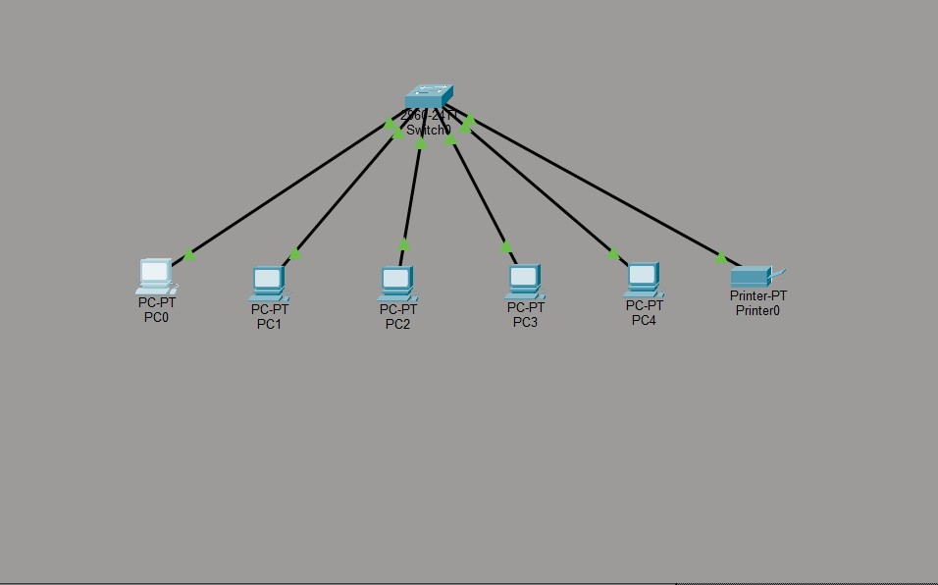
Device | IP Address | Subnet Mask
PC0 | 192.168.1.1 | 255.255.255.0
PC1 | 192.168.1.2 | 255.255.255.0
PC2 | 192.168.1.3 | 255.255.255.0
PC3 | 192.168.1.4 | 255.255.255.0
PC4 | 192.168.1.5 | 255.255.255.0
Printer | 192.168.1.10 | 255.255.255.0

Network Address: 192.168.1.0/24
Default Gateway: Not Required (No Router Used)

Procedure
- Open Cisco Packet Tracer and create a new project.
- Place one Cisco 2960 Switch in the workspace.
- Add five PCs and one Printer from the End Devices section.
- Connect all devices to the switch using Copper Straight-Through cables.
- Configure the IP address and subnet mask for each device according to the IP addressing table.
- Save the configuration.
- Open the Command Prompt on PC0 and test connectivity using the ping command with the IP addresses of the other PCs and the printer.
- Verify that all devices respond successfully, confirming proper LAN communication.

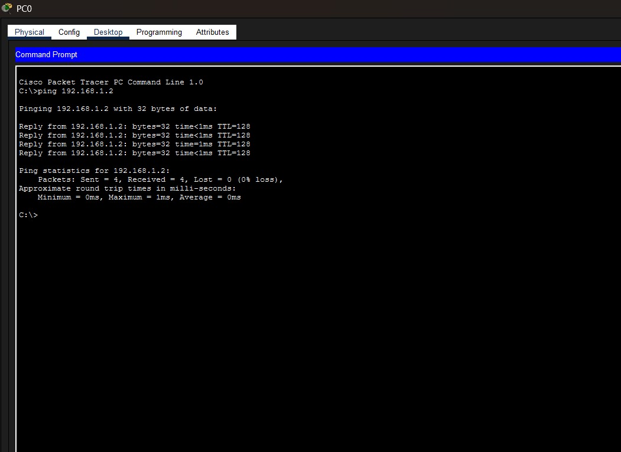

Observation
- All devices were assigned unique IP addresses within the Class C network (192.168.1.0/24).
- The switch successfully connected all devices.
- Ping tests between the computers and the printer were successful.
- The LAN operated correctly without requiring a router because all devices were on the same subnet.
The LAN topology consisting of five computers and one printer was successfully created in Cisco Packet Tracer using a Class C subnet (192.168.1.0/24). All devices communicated successfully through the switch, and the network connectivity was verified using the ping command.

Task-4

Perform a clean OS installation with Manual disk partitioning and startup optimization.
Success criteria: system passes post , all Ips are reachable via ping and the os boot without errors

To perform a clean installation of an operating system by manually creating disk partitions and optimizing the system startup for better performance and reliability.

Step 1: Prepare Bootable Media
- Create a bootable USB drive using Windows Media Creation Tool or Rufus.
- Insert the USB drive into the computer.

Step 2: Configure BIOS/UEFI
- Restart the computer.
- Enter BIOS/UEFI by pressing F2, Delete, or F12.
- Set the USB drive as the first boot device.
- Save the settings and restart.

Step 3: Install the Operating System
- Boot from the USB drive.
- Select the language, time, and keyboard layout.
- Click Install Now.
- Accept the license agreement.
- Select Custom: Install Windows only (Advanced).

Step 4: Manual Disk Partitioning
- Delete existing partitions (after backing up important data).
- Create new partitions manually.
Partition Size
System (C:) 100 GB
Data (D:) Remaining Disk Space

Format the partitions.


Select the C: drive and click Next to begin the installation.

Step 5: Complete Installation
- Wait for Windows to install.
- The computer will restart automatically.
- Complete the initial setup by creating a user account and configuring regional settings. Step 6: Install Drivers
- Open Device Manager.
- Install all required device drivers.
- Confirm that no devices show warning symbols.

Step 7: Startup Optimization
- Open Task Manager (Ctrl + Shift + Esc).
- Select the Startup tab.
- Disable unnecessary startup applications.
- Keep only essential startup programs enabled.
- Restart the computer

Observation
- The operating system was installed successfully.
- Manual disk partitioning was completed.
- Device drivers were installed correctly.
- Startup applications were optimized for faster boot performance.
- The system operated smoothly after installation.

Success Criteria
The practical is considered successful when:
- The system successfully passes the Power-On Self-Test (POST) without hardware errors.
- All configured IP addresses are reachable using the Ping command.
- The operating system boots successfully without startup errors.
- Manual disk partitions are created and recognized correctly.
- Essential device drivers are installed and functioning properly.
- Startup optimization improves the system's boot performance.

A clean operating system installation was successfully completed using manual disk partitioning. The system passed the POST process, all configured IP addresses were reachable through the Ping command, and the operating system booted without any errors. Therefore, the system met all the specified success criteria.

Section – C

Case Study Report: Troubleshooting Random Workstation Restarts Under Heavy Load

Scenario
At Nexus Innovations, three rendering workstations successfully complete the morning Power-On Self-Test (POST) but begin to restart randomly during heavy rendering workloads in the afternoon. Investigation reveals that all three systems are placed inside poorly ventilated desk cabinets, restricting airflow and causing heat buildup.

Objective
To identify the probable hardware causes of random system restarts, explain the reason behind the failures, diagnose the issue using stress-testing tools, recommend corrective actions, and determine whether upgrading the Power Supply Unit (PSU) is necessary.

1. Hardware Components Most Likely Responsible for Random Reboots
The following hardware components are the most probable causes of unexpected restarts under heavy workloads.

A. Central Processing Unit (CPU)
The CPU performs complex rendering calculations that generate significant heat. If the processor temperature exceeds its safe operating limit, the motherboard activates thermal protection to prevent permanent damage by shutting down or restarting the computer.
Possible Symptoms:
- High CPU temperature
- Sudden restart during rendering
- Reduced performance due to thermal throttling

B. Power Supply Unit (PSU)
During rendering, the CPU, GPU, memory, and storage devices consume more electrical power. If the PSU cannot provide sufficient and stable power, voltage fluctuations may occur, causing the computer to restart unexpectedly.

Possible Symptoms:
- Random restarts only during heavy workloads
- System instability
- Unexpected shutdowns without warning

C. Cooling System (CPU Cooler and Case Fans)
The cooling system removes heat generated by internal components. Dust accumulation, failed fans, dried thermal paste, or restricted airflow inside enclosed cabinets reduce cooling efficiency and increase internal temperatures.
Possible Symptoms:
- High internal temperatures
- Loud fan noise
- Frequent thermal shutdowns

2. Why the Systems Pass POST in the Morning but Fail in the Afternoon
The Power-On Self-Test (POST) is performed immediately after the computer is switched on. During the morning:
- The room temperature is relatively low.
- Internal hardware components are cool.
- The CPU has not yet been placed under heavy workload.
- Cooling systems can easily maintain safe temperatures.
Therefore, the computer successfully passes POST.
During the afternoon:
- Rendering software places the CPU and GPU under continuous heavy load.
- Heat accumulates inside the poorly ventilated desk cabinets.
- Restricted airflow prevents hot air from escaping.
- Internal temperatures continue increasing.
- Once the CPU or other components exceed their thermal limits, protective mechanisms automatically restart the computer to prevent hardware damage.
Thus, the systems operate normally when cold but become unstable after prolonged operation.

3. Using a Stress-Test Tool to Confirm a Thermal or Power Issue
A stress-test simulates maximum hardware workload to determine whether the system remains stable.

Procedure

Step 1
Install a stress-testing application such as:
- Prime95
- AIDA64
- OCCT
- Cinebench (CPU Benchmark)

Step 2
Install hardware monitoring software such as:
- HWMonitor
- HWiNFO
- Open Hardware Monitor

Step 3
Record the following values before starting the test:
- CPU Temperature
- GPU Temperature
- Fan Speed
- CPU Frequency
- Voltage Readings Step 4
Run the stress test for approximately 20–30 minutes while monitoring hardware temperatures.

Step 5
Observe the results.
If:
- CPU temperature rises above approximately 90°C
- GPU temperature becomes excessively high
- Voltage becomes unstable
- The computer suddenly restarts then the problem is confirmed as either a thermal issue or an insufficient power supply.

4. Recommended Solutions to Prevent Frequent System Restarts Solution 1: Improve Airflow and Ventilation
Remove the workstations from enclosed desk cabinets or provide adequate ventilation.
This allows:
- Better airflow
- Lower internal temperatures
- Improved cooling efficiency

Solution 2: Service the Cooling System
Perform preventive maintenance by:
- Cleaning dust from heatsinks and fans
- Replacing dried thermal paste
- Ensuring all cooling fans operate correctly
- Installing additional case fans if required
This improves heat dissipation and prevents thermal shutdown.

Solution 3: Test and Replace Faulty Hardware
Perform hardware diagnostics on:
- PSU
- CPU Cooler
- Motherboard
- RAM
Replace any component that fails diagnostic testing.

5. Technical Justification for a PSU Upgrade
A PSU upgrade should only be recommended after verifying the existing power supply.

When a PSU Upgrade is Necessary
Upgrade the PSU if:
- Power consumption exceeds PSU capacity.
- Voltage output is unstable.
- The PSU is old or showing signs of failure.
- A powerful GPU or CPU has recently been installed.
A higher-quality PSU provides stable voltage and sufficient current under heavy workloads, reducing unexpected restarts.

When a PSU Upgrade is Not Necessary
A PSU upgrade is unnecessary if:
- Voltage remains stable during stress testing.
- The PSU wattage is sufficient.
- The restarts are caused solely by overheating due to poor airflow.
In this situation, improving cooling and ventilation is a more effective solution than replacing the PSU.

Observation
- The workstations passed POST successfully when temperatures were low.
- Continuous rendering increased CPU and internal cabinet temperatures.
- Poor airflow caused excessive heat accumulation.
- Stress testing reproduced the restart issue under heavy load.
- Improving cooling significantly reduced system instability.
The issue was successfully diagnosed through hardware inspection and stress testing. After improving airflow, servicing the cooling system, and verifying power supply performance, the workstations operated normally under heavy rendering workloads without random restarts, successfully meeting the required performance and stability criteria.

